
Candidate number: ...............................................................................

Year 12 Entrance Examination Chemistry
SAMPLE PAPER

Time allowed: 45 minutes

Information for candidates:
- All questions are worth 10 marks.
- Calculators are required.
- You will find a Periodic Table on page 2 of this question booklet.

Total marks: 40

Q1
This question is about atomic structure. Use the Periodic Table to assist you.
(a) A sample of iron contains two isotopes.
(i) What are isotopes?

………………………………………………………………………………………………………………………………………………………………………………………………………………………………………………………………………………………………………………………………………………………………………………………………………………………………………………………………………………………………

(ii) Complete the table below for the two isotopes of iron.

Atomic number | Mass number | Number of protons | Number of neutrons | Percentage of each isotope in sample
 |  | 26 | 28 | 8
26 | 56 |  |  | 92

(iii) Use information from the table to calculate the relative atomic mass of
iron (i.e. the average mass of one atom of iron in this sample).
Show all your working. Give your answer to one decimal place.

(b) Suggest why, in terms of the sub-atomic particles present, the two isotopes
of iron show identical chemical properties but different physical properties.

………………………………………………………………………………………………………………………………………………………………………………………………………………………………………………………………………………………………………………………………………………………………………………………………………………………………………………………………………………………………………………………………………………………………………………………………………………………………………………………………………………………………………………………………………………………………………………………………………………………………………………………………………………………………………………………………………………………………………………………………

Q2. The table below shows the volume of hydrogen gas formed during a reaction between excess dilute hydrochloric acid and a piece of magnesium ribbon.

Time (s) | 0 | 10 | 20 | 30 | 40 | 50 | 60 | 70
Volume of gas  (cm³) | 0 | 42 | 60 | 98 | 108 | 110 | 110 | 110

(a) (i) Plot the data on the grid below and, using a pencil, draw a smooth curve
through the reliable points.

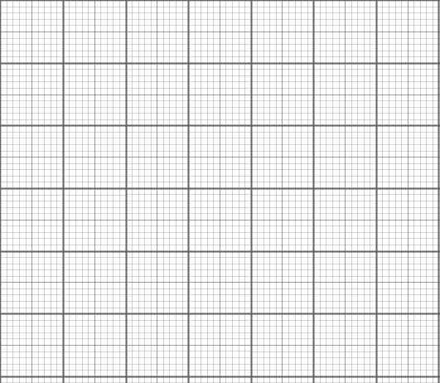

(ii) The rate of reaction at any time during the experiment is calculated by drawing a straight line tangent to the curve and calculating the gradient of this straight line.
Time (seconds)
Volume
of gas (cm³)

On the graph, use your ruler to draw a tangent to the curve at 30 s.
Showing all your working below, calculate the gradient of the straight line you have drawn. Give your final answer to TWO significant figures, in suitable units.

(iii) Explain why the volume of gas remains at 110 cm³ for the last three readings
in the table.

………………………………………………………………………………………………………………………………………………………………………………………………………………………………………………………………………………………………………………………………………………………………………………………………………………………………………………………………………………………………

(iv) Write the balanced chemical equation for the reaction between magnesium metal
and dilute hydrochloric acid. Include state symbols in your equation.

(v) Explain, in terms of particles, why the reaction is faster when hydrochloric acid
of a higher concentration is used.

…………………………………………………………………………………………………………………………………………………………………………………………………………………………………………………………………………………………………………………………………………………………………………………………………………………………………………………………………………………………………………………………………………………………………………………………………………………..…
Q3
The table below shows some data for the Group 7 elements:
Halogen | Colour | Boiling point / ºC | Magnitude of  electron affinity / kJ/mol
Fluorine | Yellow | -188
Chlorine | Green | -35 | 349
Bromine | Brown | 59 | 325
Iodine | Grey-black | 184 | 295

- Astatine is the next element in Group 7. Give the molecular formula for astatine

- Use the trends in the table to predict the physical appearance of astatine at room temperature. Explain your prediction.

………………………………………………………………………………………………………………………………………………………………………………………………………………………………………………………………………………………………………………………………………………………………………………………………………………………………………………………………………………………………………………………………………………………………………………………………………………………………………………………………………………………………………………………………………………………………………………………………………………………………………………………………………………………………………………………………………………………………………………………………………………………………………………………………………………………………

- Explain what happens when a chlorine atom becomes a chloride ion and draw a dot and cross diagram for the chloride ion (show all shells of electrons)

……………………………………………………………………………………………………………………………………………………………………………………………………………………………………………………………………………………………………………………………………………………………………………………………………………………………………………………………………………………
- Electron affinity is a measure of how much energy is released when a halogen becomes a halide ion e.g. when a chlorine atom becomes a chloride ion. State and explain the trend in electron affinities given in the table (ignore fluorine).

………………………………………………………………………………………………………………………………………………………………………………………………………………………………………………………………………………………………………………………………………………………………………………………………………………………………………………………………………………………………………………………………………………………………………………………………………………………………………………………………………………………………………………………………………………………………………………………………………………………………………………………………………………………………………………………………………………………………………………………………………………………………………………………………………………………………………………………………………………………………………………………………………………………………………………………………………………
Q4. Arrange the four oxides below in order of increasing melting point. Explain your arrangement in terms of the structure and bonding of each compound.

MgO Al₂O₃ SiO₂ CO₂

……………………………………………………………………………………………………………………………………………………………………………………………………………………………………………………………………………………………………………………………………………………………………………………………………………………………………………………………………………………………………………………………………………………………………………………………………………………………………………………………………………………………………………………………………………………………………………………………………………………………………………………………………………………………………………………………………………………………………………………………………………………………………………………………………………………………………………………………………………………………………………………………………………………………………………………………………………………………………………………………………………………………………………………………………………………………………………………………………………………………………………………………………………………………………………………………………………………………………………………………………………………………………………………………………………………………………………………………………………………………………………………………………………………………………………………………………………………………………………………………………………………………………………………………………………………………………………………………………………………………………………………………………………………………………………………………………………………………………………………………………………………………………………………………………………………………………………………………………………………………………………………………………………………………………………………………………………………………………………………………………………………………………………………………………………………………………………………………………………………………………………………………………………………………………………………………………………………………………………………………………………………………………………………………………………………………………………………………………………………………………………………………………………………………………………………………………………………………………………………………………………………………………………………………………………………………………………………………………………………………………………………………………………………………………………………………………………………………………………………………………………………………………………………………………………………………………………………………………………………………………………………………………………………………………………………………………………………………………………………………………………………………………………………………………………………………………………………………………………………

