Year 12 Entrance Examination Geography Sample paper


Name: ...............................................................................
School: .............................................................................

Time allowed: 45 minutes

Instructions
There are two parts to the test: A and B. You must complete both parts.

Part A: Problem solving and Critical thinking
There are two sub-sections to this part of the test. Each sub section requires you to analyse data or read a passage and then answer some multiple-choice questions.
Suggested timing: 20 minutes

Part B: Essay
This section requires you to answer the essay question set. Please include a plan for your response.
Suggested timing: 25 minutes

Mark Allocation
Section A | Problem solving and critical thinking | 13
Section B | Essay | 20
Total |  | 33

Section A – Problem solving and critical thinking
Sub-section (i): Problem solving
Study the two maps below. Map 1 shows GDP per capita, 2023 and Chart 2 shows expected years of schooling vs. share in extreme poverty, 2023.

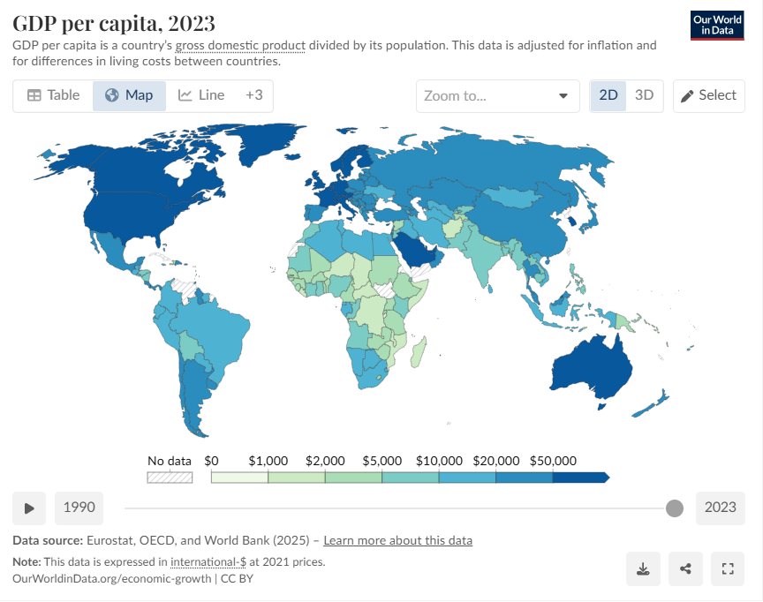
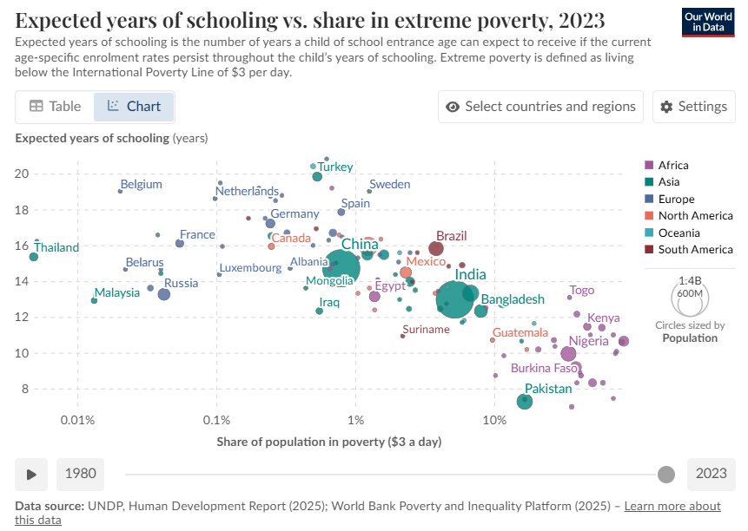
- Based on the information provided in Map 1 (GDP per capita, 2023), which one of the following statements is true?
  - All countries in South America have GDP per capita above $20,000.
  - Russia has a higher GDP per capita than most Western European countries.
  - Sub-Saharan Africa generally has some of the lowest GDP per capita values worldwide.
  - GDP per capita is uniform across Asia.
  - Greenland has one of the lowest GDP per capita figures globally.

- Based on the information provided in Chart 2 (Schooling vs. extreme poverty), which one of the following is not true?
  - Sub-Saharan African countries such as Burkina Faso, Nigeria, and Kenya combine low schooling years with high extreme poverty.
  - Pakistan has relatively low expected years of schooling and high levels of extreme poverty compared to most Asian countries.
  - Brazil and Mexico show higher levels of extreme poverty than most European countries but still achieve expected years of schooling above 14.
  - China has a high proportion of its population living in extreme poverty. Belgium, the Netherlands, and Sweden have high expected years of schooling and very low levels of extreme poverty.

- Which one of the following statements, if true, would help explain a trend observable across the two maps?
  - Countries with high GDP per capita consistently have higher levels of extreme poverty.
  - Higher GDP per capita often allows governments to spend more on education, leading to higher expected years of schooling.
  - African countries with high poverty rates have the same school enrolment rates as Europe.
  - Education investment is unrelated to economic development.
  - Countries with small populations always have the highest schooling years.

- Based on the information provided in both graphs, which one of the following is a reasonable summary?
  - Countries with the highest GDP per capita generally have both lower poverty rates and higher expected years of schooling.
  - Countries with the lowest GDP per capita always have the longest expected years of schooling.
  - Extreme poverty and schooling appear unrelated across different regions.
  - Asia shows consistently higher levels of extreme poverty than Africa.
  - All European countries have identical education outcomes.

- Which of the following would be a reasonable conclusion to draw from the data?
  - The relationship between GDP per capita and education levels is completely random.
  - Africa’s education outcomes are higher than Europe’s despite higher poverty levels.
  - High GDP per capita often correlates with reduced extreme poverty and increased years of schooling.
  - Brazil has the lowest expected years of schooling in South America.
  - Countries with high schooling years always have very high GDP per capita.

- Which one of the following statements best describes the relationship between poverty and education in the chart?
  - Countries with high poverty tend to have the highest expected years of schooling.
  - Extreme poverty has no effect on expected years of schooling.
  - Only South American countries show a clear relationship between poverty and education.
  - Higher poverty levels are generally linked with fewer expected years of schooling.
  - Countries with large populations tend to have the lowest levels of poverty.

- Which of the following is supported by the evidence in both datasets?
  - India has a GDP per capita above $50,000, which explains its high schooling years.
  - The Democratic Republic of Congo has one of the highest GDP per capita values globally.
  - Western Europe has both very low levels of extreme poverty and some of the highest GDP per capita figures.
  - North America has higher levels of extreme poverty than Sub-Saharan Africa.
  - Bangladesh shows extremely low poverty levels combined with some of the highest schooling years globally.

Sub-section (ii): Critical thinking

Should China worry about its shrinking population?
20 January 2023

Image source, EPA
Image caption: China's statistics bureau said this week that its population has fallen for the first time in 60 years, with the birth rate also hitting a record low
By Kelly Ng
BBC News

China's population has fallen for the first time in six decades, official statistics revealed earlier this week - but this trend may not spell doom for the country in the short term, experts say.
Beyond 2030, however, demographic stress will be a drag on growth in what is currently the world's second-largest economy.
The number of Chinese people fell by 850,000 from the previous year to 1.4118 billion, the statistics showed. Its birth rate had been slowing for years, prompting a range of policies to try to slow this trend, including scrapping the country's infamous one-child policy seven years ago.
But there are no easy fixes to this conundrum, economists and demographers say, given the unique trajectory in which the Chinese population has aged in recent years.
While ageing populations have posed a challenge to economies around the world, the greater concern for China is the rapid pace at which this has been unfolding in the midst of its middle-income transition.
In short, China is getting old before it gets rich.
Its statistics bureau said this week that its population had fallen for the first time in 60 years, with the birth rate also hitting a record low - to no surprise. Some researchers believe the population decline started in 2018 and census estimates have been inaccurate.
In any case, China's working-age population has been on a slump since 2012. Its age-dependency ratio, which is the ratio of children and retired people to the working age population, has risen from 37.12% in 2010 to 44.14% in 2020.
Based on UN estimates, the number of Chinese aged between 15 and 64 will fall by more than 60% this century.
But Andrew Harris, deputy chief economist at Fathom Financial Consulting, said the country had a pool of cheap rural labour that could help fill manufacturing gaps in urban areas.
There is still "significant slack" in the manufacturing and construction sectors, Mr Harris added, noting that Fathom estimates that roughly one third of workers in the construction sector are underemployed, which means they are producing less than they potentially could.
"The broader demographic story won't bite fully on China's growth until both of these sources of slack have been exhausted," he said.
According to Paul Cheung, Singapore's former chief statistician, China has "plenty of manpower" and "a lot of lead time" to manage the demographic challenge.
"They are not in a doomsday scenario right away," Prof Cheung said.
He also pointed to how countries like Japan and Singapore had managed to provide a safety net for their ageing citizens while maintaining relative economic stability.
But not everyone is as sanguine.
"The major difference between China and countries like South Korea and Japan is that its demographic (stress is) biting at much lower levels of income," Mr Harris said.
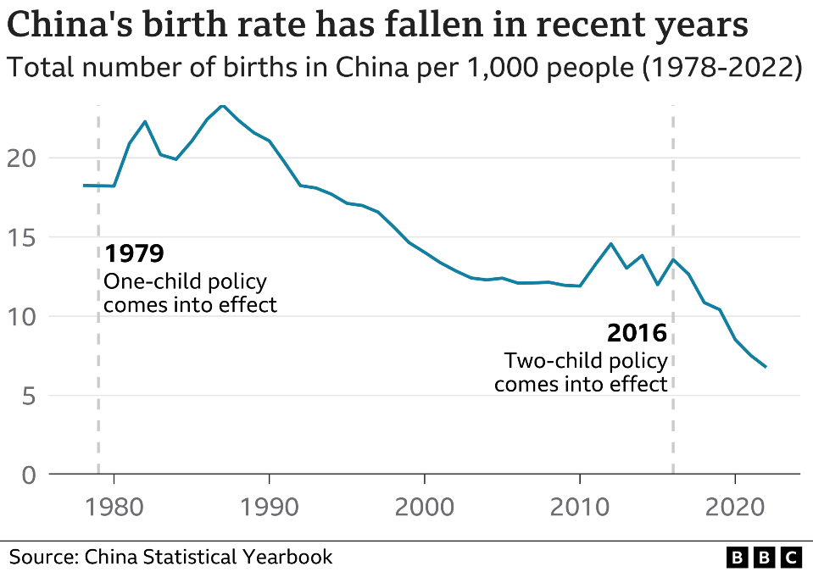
A 2019 report by the Chinese Academy of Social Sciences predicted that the country's main pension fund would be depleted by 2035, in part because of its shrinking workforce.
Studies by US think-tank Pew Research showed that some seven in 10 people in China already felt its public health system was under strain in 2016. A greying population and the spiralling Covid crisis have placed additional stresses on it.
China's population decline could send ripple effects across the global economy.
For one, a shrinking workforce means rising labour costs, which could increase consumption and production costs. Recent reports have already shown China - long dubbed the "factory of the world" - losing manufacturing operations to other developing countries in Asia and South America.
"China's shrinking labour force and manufacturing recession will lead to high prices and high inflation in the US and EU," said Yi Fuxian, a researcher at the University of Wisconsin-Madison and longtime critic of China's now-defunct one-child policy.
Given how its recent attempts to raise fertility rates have met with limited success, China may have to look at other ways to sustain growth.
This will involve making hard political decisions, said George Magnus, an independent economist and associate at the China Centre at Oxford University.
For instance, it should consider national legislation to raise retirement ages, Mr Magnus said. The current retirement age for most men in China is 60, while the OECD average is 64.2. The number stands at 55 for female civil servants and 50 for female blue-collar workers.
However, previous calls to raise the retirement age have sparked backlash in China, with older workers not wanting to delay access to their pensions.
China is already pursuing automation through robotics and artificial intelligence, but the impact on productivity is still unclear, Mr Harris said.
Another solution would be to bolster the population through immigration, although this is not an option that the Chinese Communist Party has favoured historically, he noted.
Although China can no longer rely on its demographic dividend to fuel its economy, that may not be a bad thing if it manages to seek growth from other sources such as productivity, some observers say.
"We should be much more nuanced about the stall in China's population growth. Planetary sustainability and urban congestion are better served by a more stable world population, which may entail declines in some countries," Mr Magnus said.
"Demography is not destiny. The key is to get these and other nations to focus like a laser beam on 'coping mechanisms'."
- Which one of the following statements best summarises the author’s understanding of China’s demographic challenge?
  - China’s population decline signals an immediate collapse of its economy and society.
  - China’s shrinking population poses serious long-term risks but does not amount to a short-term crisis.
  - China’s demographic stress will be solved naturally as fertility rates rise in coming years.
  - China’s population will stabilise once more people migrate from rural to urban areas.
  - China’s population decline mirrors Japan’s experience and will produce similar outcomes.

- Which one of the following statements best reflects the author’s main concern about the pace of China’s demographic change?
  - It is happening while China remains a middle-income country, limiting its ability to cope.
  - It is happening more slowly than in other countries, reducing incentives for reform.
  - It is mostly the result of inaccurate census data and statistical errors.
  - It is driven entirely by the one-child policy rather than wider social trends.
  - It is caused primarily by mass emigration of working-age Chinese people.

- Which one of the following statements best summarises the article’s main conclusion?
  - China’s falling population will inevitably lead to economic collapse and global instability.
  - While China can no longer rely on its demographic dividend, it can adapt through reforms, innovation, and productivity growth.
  - Immigration offers the only realistic solution to China’s population decline.
  - China should abandon attempts at fertility policies and instead focus entirely on automation.
  - The decline in China’s population will have no significant impact on global markets.

- Which one of the following assumptions does the author’s argument depend on most strongly?
  - China’s ageing population will strain pensions and health care systems unless structural reforms are introduced.
  - Rising fertility rates will quickly offset the effects of population decline.
  - The Chinese Communist Party will eventually encourage large-scale immigration.
  - China’s rural labour force will continue to supply manufacturing without limits.
  - Technological automation will immediately erase the impact of demographic decline.

- Which one of the following statements is not consistent with the author’s argument?
  - Raising the retirement age could help sustain China’s workforce, but such reforms face political resistance.
  - Other countries like Japan and Singapore show that ageing societies can still achieve economic stability.
  - China’s declining population will push up labour costs and could shift manufacturing to other countries.
  - Because demographic change is destiny, China’s long-term decline cannot be mitigated by policy choices.
  - Some observers argue that slower population growth may bring environmental and social benefits.

- Which one of the following ideas does the article most directly challenge?
  - That a shrinking population must always result in national decline.
  - That ageing populations are a uniquely Chinese phenomenon.
  - That fertility policies alone can reverse population decline.
  - That China’s role as “factory of the world” is entirely secure.
  - That economic growth depends solely on demographic size.

Essay question:
To what extent are the challenges facing a place of your choice greater than the opportunities it presents?

Additional space

