This is not a test of knowledge. You will be assessed on how carefully you record your visual analysis and how thoughtfully you make use of the other information provided here. We will also give credit for good use of English.
Approximate timings for the questions have been provided for your guidance.

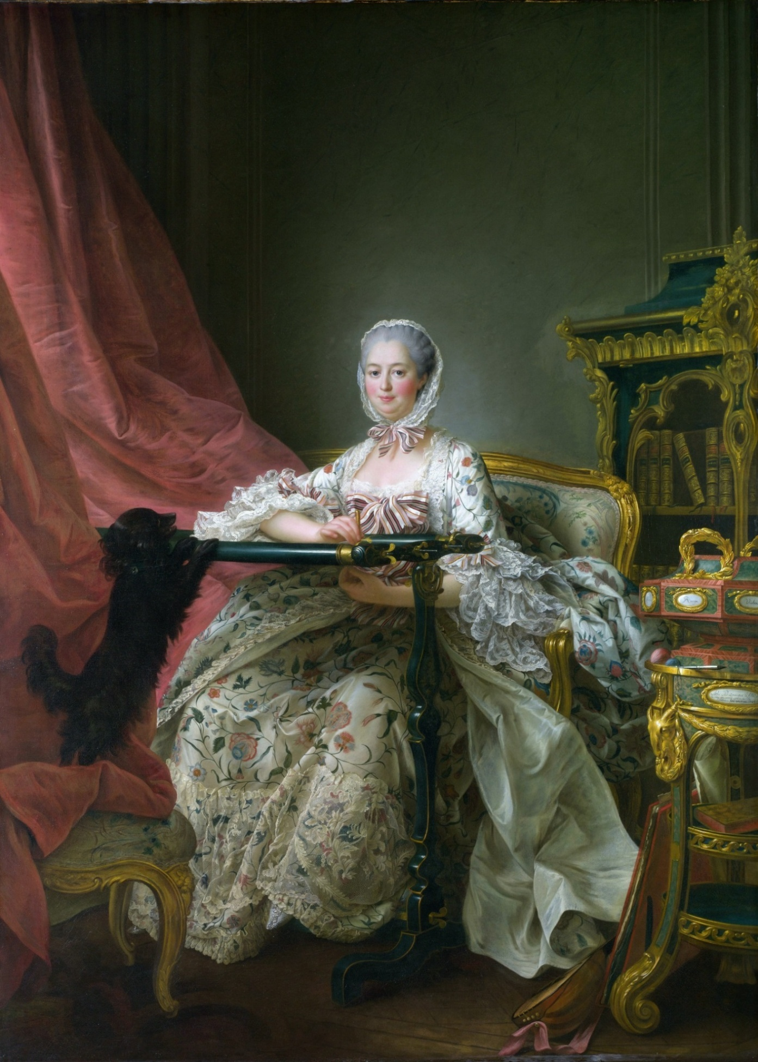
François-Hubert Drouais, Madame de Pompadour at her Tambour* Frame, (*embroidery frame)
1763-64 (oil on canvas) (217 cm x 156.8 cm)
National Gallery London
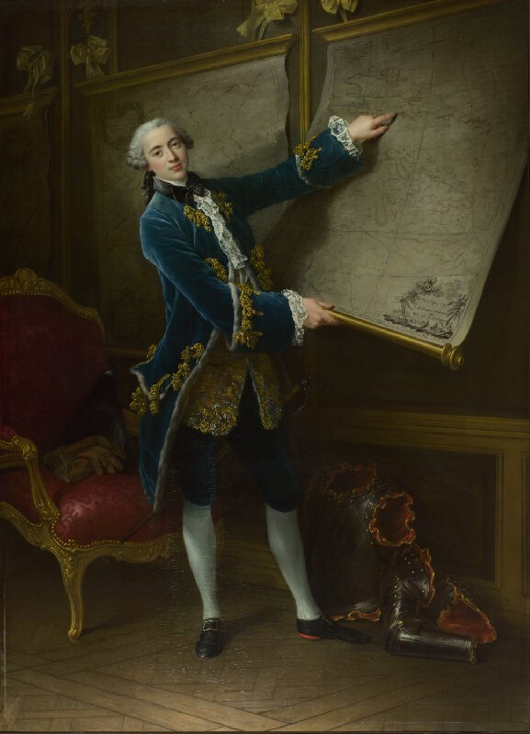
François-Hubert Drouais Le Comte de Vaudreuil
1758 (oil on canvas) (225 x 161.3 cm)
National Gallery London

Part 1: 15 minutes
To answer this question you only need look closely at the illustrations. Do not read on in the examination until you have tackled this first section. Your written response should include close reference to the works.

These two paintings are by the same French society portrait painter, François-Hubert Drouais who was the chief portrait painter at the court of Louis XV in France. He portrayed most of the leading figures of his age. These two paintings are excellent examples of the grand scale, attention to detail and somewhat idealising portraits, for which he was sought after and celebrated.

- Analyse the representation of the figure and their setting in the two portraits.

- Compare and contrast both paintings and evaluate what we learn about male and female roles at that time.

Part 2 Reading 5-10 minutes and writing 20 minutes
In the study of History of Art, works are interpreted in the light of the historical context. In this second section, you will be given some information about Madame de Pompadour in two documents. After you have digested these try answering the questions below.

- Using your new knowledge of the life of Madame de Pompadour, return to the François-Hubert Drouais’s Madame de Pompadour at her Tambour Frame and comment on how this portrait reflects the discussion of the status of this particular and powerful 18th century woman. 10 minutes

- “..theatricality in Pompadour's case involved more than metaphor.” Summarise the author’s claims. Can a portrait be said to be like taking on a theatrical role? Discuss how that might apply to this portrait of Madame de Pompadour or if you have another portrait that you know well, feel free to use it to answer the question. 10 minutes

I hope you might visit The National Gallery where both paintings are on show albeit in different rooms.
Understanding the context of all works of art open up exciting journeys into their meaning and purpose.

Document 1:
Madame de Pompadour was born Jeanne-Antoinette Poisson in 1721. She was an ‘illegitimate’ (born outside marriage) daughter of Francois Poisson who made his fortune working for a family of powerful bankers. Despite these rather ignoble roots she was still prepared for success in high circles. Her schooling was complemented by voice and elocution lessons from the stars of Parisian opera and theatre.
In 1745 she became the mistress of King Louis XV. She was determined that this would not be a short term affair. Once she had secured an apartment at Versailles, she arranged a formal separation from her husband and was given the title of the Marquise de Pompadour and a coat of arms. With her status and power, the Marquise of Pompadour helped to promote French luxury goods through her patronage. She was particularly associated with the manufacture of Sèvres porcelain, as well as contemporary furniture and tapestry.
Over two decades the Marquise de Pompadour took the role of close friend, personal confident, policy consultant, governmental aide, cultural impresario and artistic patron. Some even considered her to have taken on the role of a de facto * prime minister. Having gained so much influence – and having begun life as plain Jeanne-Antoinette Poisson – she attracted as many enemies as she did supporters. What is certain is that her affection, her charm, and above all her interest in music, theatre and the arts made her a considerable figure in a society where women almost universally had highly restricted roles. She was to remain very close to the King until her death in 1764 aged just 43 shortly before the completion of this, her last portrait.
(*existing or holding a specified position in fact but not necessarily by legal right)
Document 2
Madame de Pompadour was routinely said to have entered the domain of public power normally reserved for men … she was referred to as a "Prime Minister" and there were some, such as the Duc de Choiseul, who contended that she even aspired to become king.
Drawing upon a rich discursive tradition in which the dynamics of court politics were described through theatrical figures of speech, contemporaries who believed Pompadour to have a determined will to power persistently pointed to connections between Pompadour's ambitions and her theatrical art. ... Charles Duclos, for example, in describing the connection between Pompadour's theatre and her political career, wrote that Pompadour "was not insensible to the idea of playing a role more noble than she had played in the theatre of the [king's] apartments. In entering politics, she thought of herself as a personage of state and believed she had all the talents."
Yet theatricality in Pompadour's case involved more than metaphor, for it relates to the way in which she was thought to disguise her power relationships with the king and court. Many observers commented on the "art" of drawing attention away from her real goal of gaining power, and here the reference to her theatre was not merely metaphorical. The Duc de Croy, for example, wrote that Pompadour "intervened in many things without giving the impression of doing so or appearing to be concerned with them. On the contrary, she affected, either by nature or design, to be preoccupied more with her little comedies or other theatrical performances than with anything else.”.
“Madame de Pompadour and the Theatres of Power” Author: Thomas E. Kaiser
French Historical Studies, Vol. 19, No. 4, (Autumn, 1996),pp. 1025-1044 Duke University

