

Name: ...............................................................................
School: ................................................................................

Year 12 Entrance Examination Mandarin

Time allowed: 45 minutes

Instructions/information

- This exam consists of three sections
Section 1 and 2 are reading comprehension exercises
Section 3 is a writing task

- Complete all three sections. After 20 - 25 minutes, move to Section 3 even if you have not been able to complete Sections 1 and 2

- You may use blank pages to make notes

- No dictionaries are allowed

Session 1

阅读以下短文。选择唯一正确的答案，在方格里打勾（）。
Select one correct answer and put in the square.
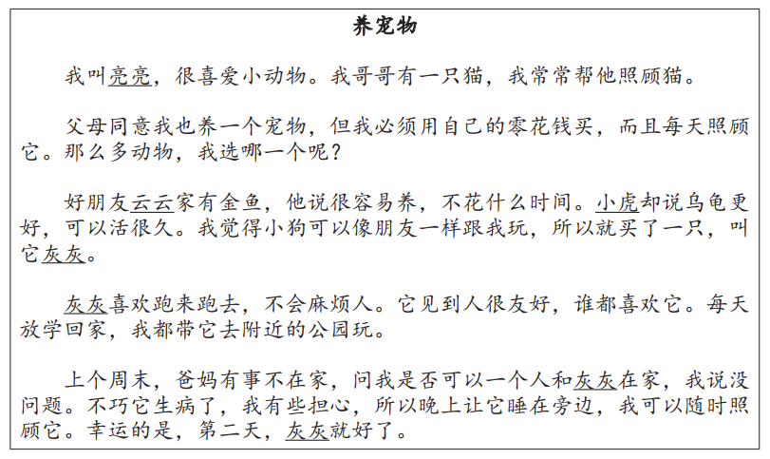

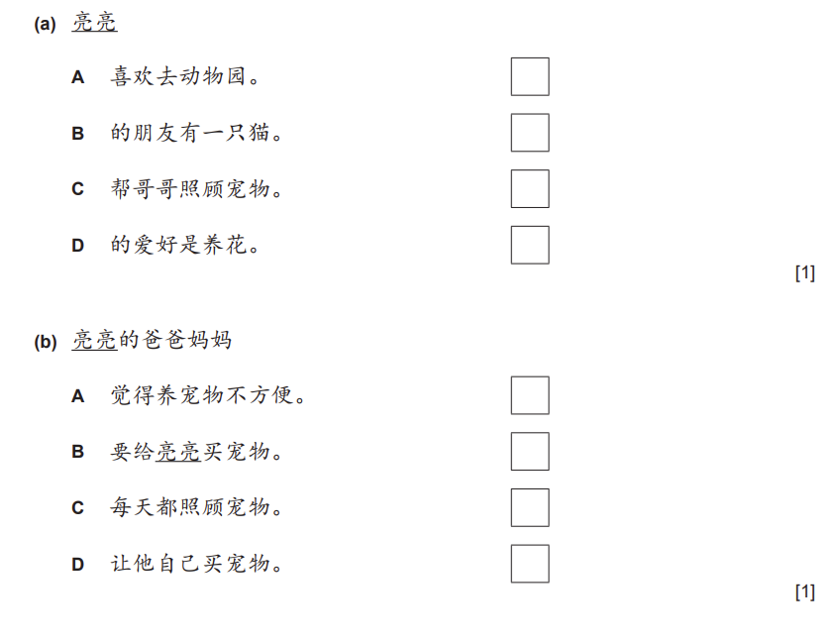
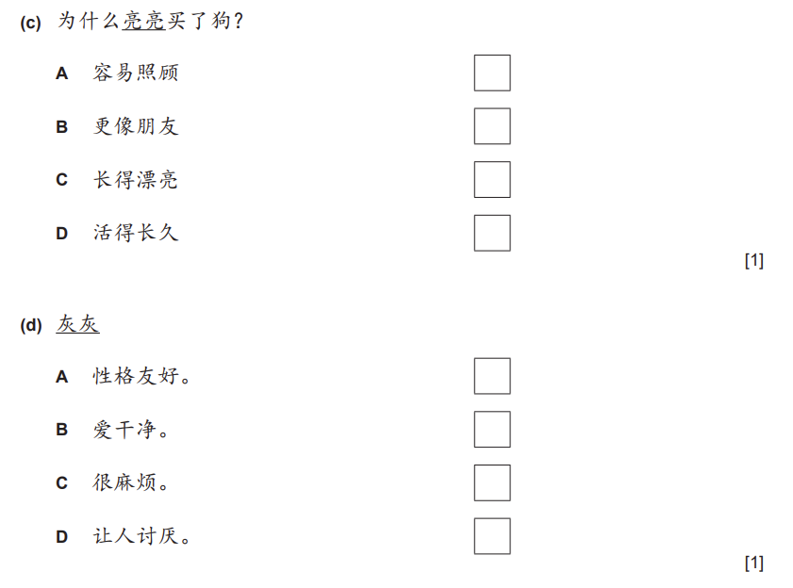

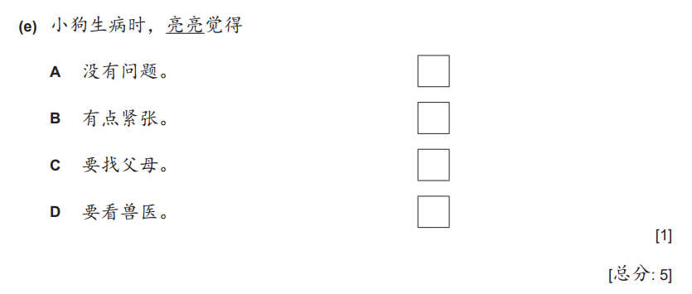

Session 2
阅读以下短文，用中文回答问题。
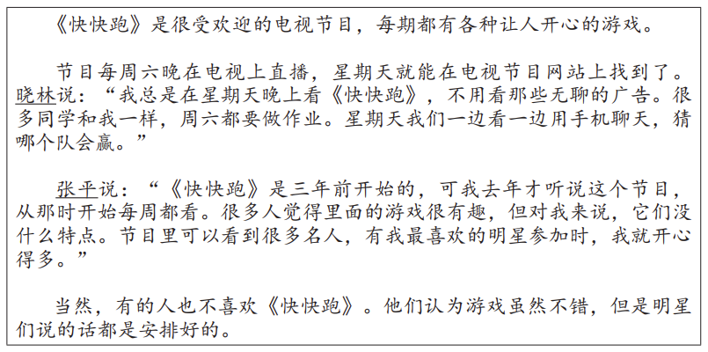

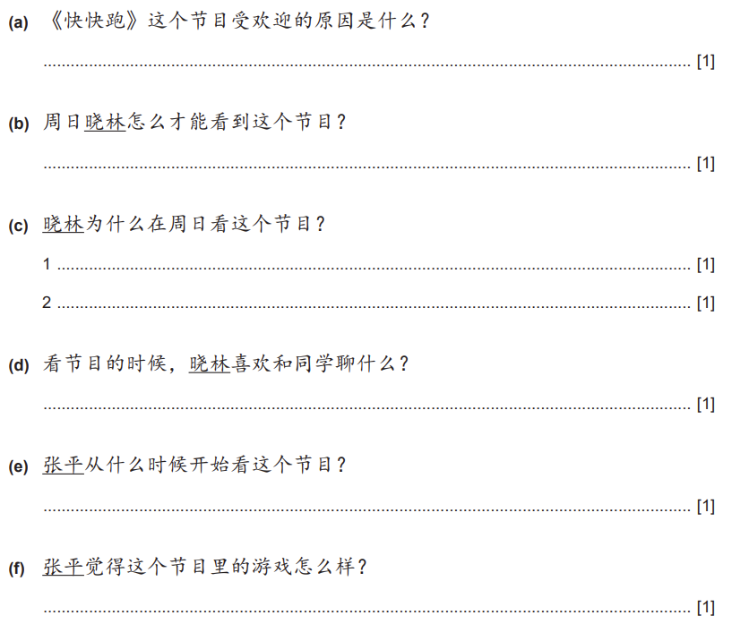.......

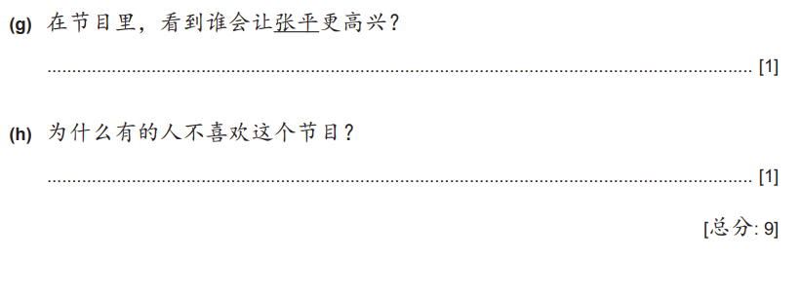

Session 3

从题目3(a)或者3(b)中选择一个，用中文写150个字左右。
Answer Question 3(a) or Question 3(b). Write about 150 characters in Chinese.
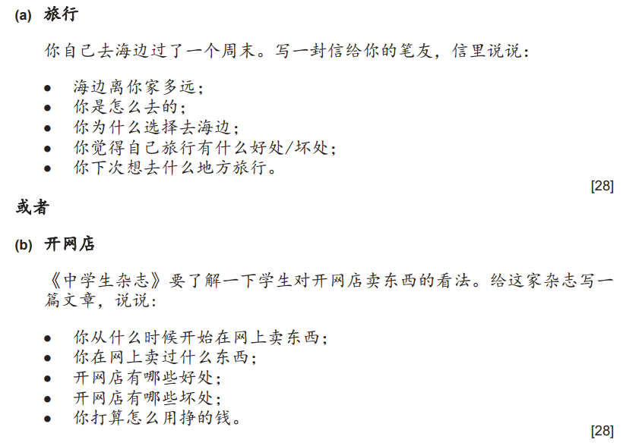 Content 10 marks, range of language 10 marks, accuracy 8 marks.

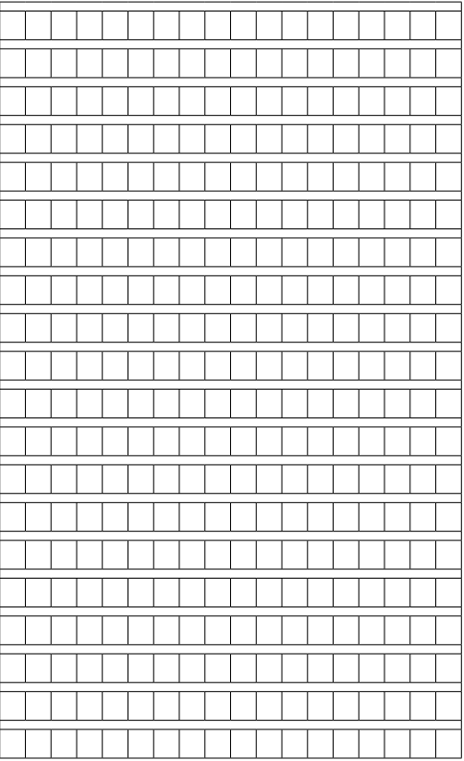
- End of test –
- Blank page -

