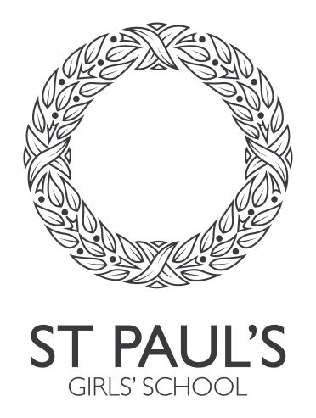

Name: ...............................................................................

School: .............................................................................

Instruments played (with grades taken if applicable) / ensembles that you are in: …………………………………………………………………………………………………………………………………………………………………………………………………………………………………………………………………………………………………………………………………………………………………………………………………………………………………………………….

Year 12 Entrance Examination Music October 2025

Time allowed: 45 minutes

Instructions / Information for candidates:

- For this paper you must have: Sections A-D - audio tracks and playback equipment.

- The marks for each question are shown in brackets.

- You must answer questions in the spaces provided. Use black ink or ball-point pen. You may use pencil for music notation.

 | MARKS AVAILABLE | MARK
Section A | 24
Section B | 11
Section C | 14
Section D | 15
TOTAL | 64
Total %:

BLANK PAGE

SECTION A (24 marks)

You will hear six short extracts of music written by women.

Put an answer for each of the specified features. One mark is available for each.

Extract 1
Time signature:
Texture:
Musical period:
Solo instrument:

Extract 2
Tonality:
Time signature:
Genre:
Possible composer (male or female):

Extract 3
Texture:
Genre:
Possible year of composition:
Is the word setting syllabic or melismatic:

Extract 4
Percussion instrument heard throughout:
Genre:
Main Tonality:
Possible year of composition:

Extract 5
Tonality:
Time signature:
Genre:
Possible composer (male or female):

Extract 6
Time signature:
Tonality:
Genre:
Musical period:

TOTAL /24

SECTION B (11 marks)
You will hear the opening of a Rondo by Mozart.
The extract begins with the orchestra playing eight four-bar phrases before the piano enters. The first phrase (A1) is shown below:

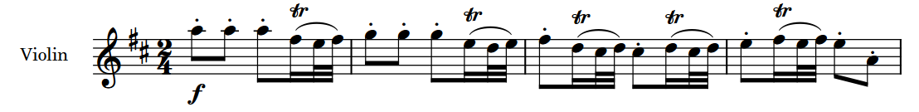

- Complete the table below to describe the structure of the orchestral music. The first four phrases have been completed for you. [4]

Phrase: | 1 | 2 | 3 | 4 | 5 | 6 | 7 | 8
Section: | A1 | A2 | A1 | A2

- Name the cadence at the end of phrase 1: [1]

- Name the cadence at the end of phrase 2: [1]

- Phrases A1 and A2 are harmonised using only two chords. Name the chords using Roman numerals. [2]

- The piano follows with two eight-bar phrases. Describe the dynamics of these two phrases. [3]

TOTAL: /11

SECTION C (14 marks)

You will hear three extracts of music.

Describe the musical features of the extracts, which come from pieces written or produced in 1965.

Extract 1
Comment on instruments, harmony and texture
[5]
- Instruments (make 2 points)

- Harmony (make 1 point)

- Texture (make 2 points)

Extract 2
Comment on tempo, vocal melody and tonality
[5]
- Tempo (make 2 points)

- Vocal melody (make 2 points)

- Tonality (make 1 point)

Extract 3
Comment on structure, rhythm and metre and brass instruments
[4]
- Structure (make 1 point)

- Rhythm and metre (make 2 points)

- Brass instruments (make 1 point)

TOTAL /14

SECTION D (15 marks)

You will hear two extracts from a theme and variations for chamber orchestra.

Extract 1 – Theme

Here are the first four bars of the theme.

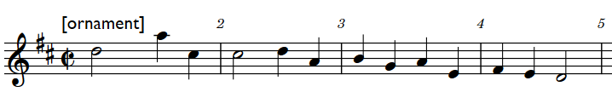

- What instrument is playing the melody? [1]

- What ornament do you hear in the melody part in bar 1, beat 2? [1]

- In what key does the first phrase end (bar 4)? (choose 1) [1]

Tonic Sub-dominant Dominant Relative minor

- In what key does the second phrase end? (bar 8) (choose 1) [1]

Tonic Sub-dominant Dominant Relative minor

- Fill in the missing five notes from b.6-7 (0’13” in the extract). The rhythm is given above the stave. [5]

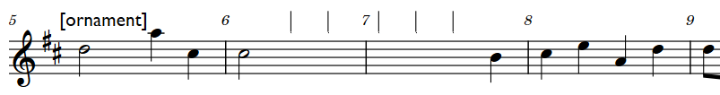

Extract 2 – Variation I

- What is the time signature of this variation? [1]

3/4 6/8 9/8

- How many instruments are playing at the beginning of variation I? [1]

In questions 8 and 9 you will not be credited for repeating information given in previous answers

- Give two similarities between the theme and the variation. [2]

- Give two differences between the theme and the variation. [2]

TOTAL /15

