
Name: ............................................................................ School: .................................................
Candidate Number: .....................................................................................................................

Year 12 Entrance Examination Physics SAMPLE

Time allowed: 45 minutes

Instructions:

- Try ALL of the questions in Section A.
- Choose only ONE of the THREE questions in Section B.
- Section A is worth 20 marks and Section B is worth 10 marks.
- Don’t spend too long on any one question.
If you’re finding a particular question difficult, move onto the next one. You can always go back to the tricky one if you have time.
- Write all your answers in the spaces provided on the question paper.
- Feel free to use a calculator.

A list of useful equations is given inside the paper.

A | B | Total
/20 | /10 | /30

Useful equations and data

Don’t worry if you haven’t met some of these before – you will not necessarily need to use them all in the test!

Take g, the acceleration due to gravity near the Earth’s surface, to be 10 m/s² (or 10 N/kg).

pressure = force
area

speed = distance
time taken

wave speed = frequency × wavelength

density = mass
volume

work done = force × distance moved in the direction of the force

power = (energy or work) / time

power = force x velocity

efficiency = (useful energy [or power] output) / (total energy [or power] input)

momentum = mass × velocity

force = mass × acceleration

force = rate of change of momentum = change in momentum
time taken

acceleration = change in velocity
time taken

weight = m g

kinetic energy = 1/2 m v² for a body of mass m moving with speed v

change in gravitational potential energy = mgh
(for a body of mass m moved through a height h)

resistance = voltage / current

electrical power = current × voltage

total charge = current × time

speed of sound in air = 330 m/s

speed of light in air = 3 × 10⁸ m/s

SECTION A

There are 20 questions. Try ALL the questions in this section.

Each question is worth 1 mark. Some are easier than others, so don’t spend too long on any one question.

Section A: Multiple Choice

For the following 20 questions, CIRCLE the letter of the correct answer

1.

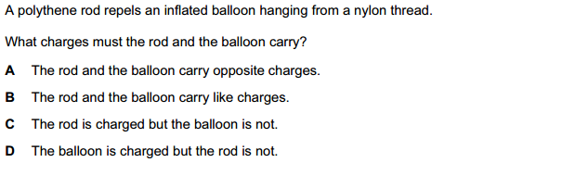

2.

A battery and three identical lamps are connected as shown:

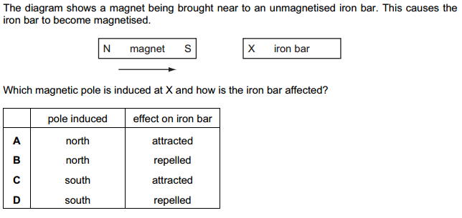
3.

The Earth’s gravitational field is stronger in Britain than in Brazil.
100kg of sugar is to be loaded on board a ship in Brazil.

You will get the highest mass reading on the scales when the sugar is unloaded in Britain, if

A the Brazilian port loads 100kg of sugar using Brazilian scales, and the British port uses
British scales

B both ports use Brazilian scales

C both ports use British scales

D the Brazilian port uses British scales, and the British port uses Brazilian scales.

4.

Which one of the following circuits has the largest total resistance?

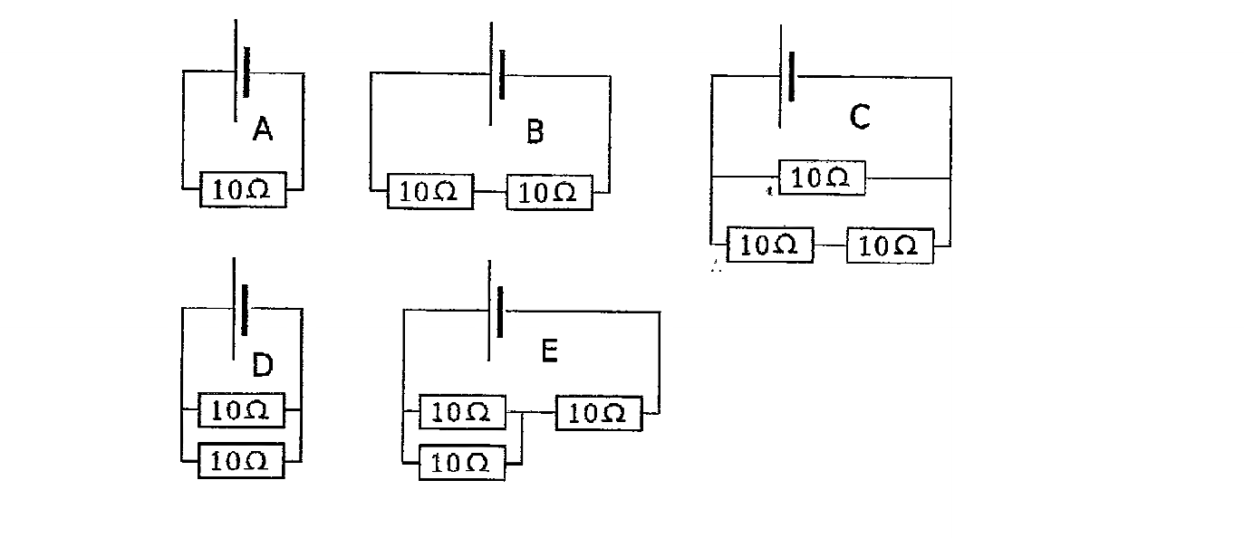

5.

A double-decker bus is in danger of being blown over on a very windy day.
To make it more stable, the driver should ask all the passengers to…

A spread out evenly all over the bus.

B all sit down, upstairs.

C all stand up, downstairs.

D all lie down, downstairs.

E spread out evenly, but only upstairs.

6.

A uniform ruler is 100 cm long. A 0.6 N weight is placed at the 80 cm mark.
The ruler is balanced in equilibrium on a pivot placed at the 60 cm mark.

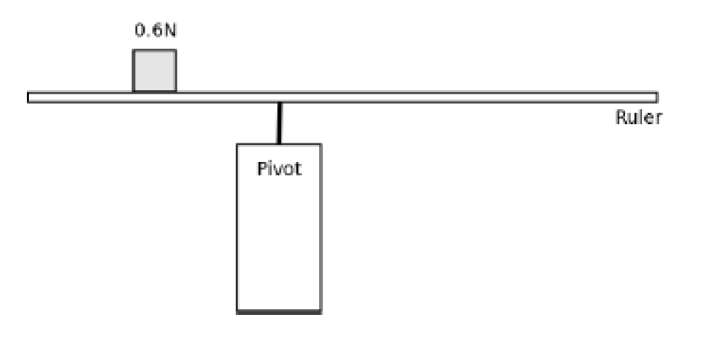

The weight of the ruler is:

A 1.2 N B 1.0 N

C 0.6 N D 0.5 N

E 0.3 N

7.

Why do we have seasons on Earth?

A The Earth is closer to the Sun in summer than it is in winter.
B The Sun is brighter in summer than it is in winter.
C The Earth's axis is tilted with respect to the plane of its orbit around the Sun.
D The orbit of the Earth around the Sun is an ellipse, not a circle.
E The Earth’s rotational axis precesses.

.
8.

Astronauts’ spacesuits are usually a white or a silver colour because…

A silver is a good conductor of heat and of electricity
B silver and white are poor radiators and good reflectors of infrared radiation
C a silver or white spacesuit will reduce heat loss due to evaporation
D silver and white colours prevent convection currents from flowing
E silver and white are good absorbers of infrared radiation.

9.

On the Moon, if you drop a hammer and a feather, they fall at exactly the same rate and hit the ground at the same time.

This is because…
A objects with different masses always fall at the same rate.
B there is no gravity on the Moon.
C both the hammer and the feather will reach a terminal velocity at the same time.
D all objects have the same weight on the Moon.
E the Moon has no atmosphere.

10.

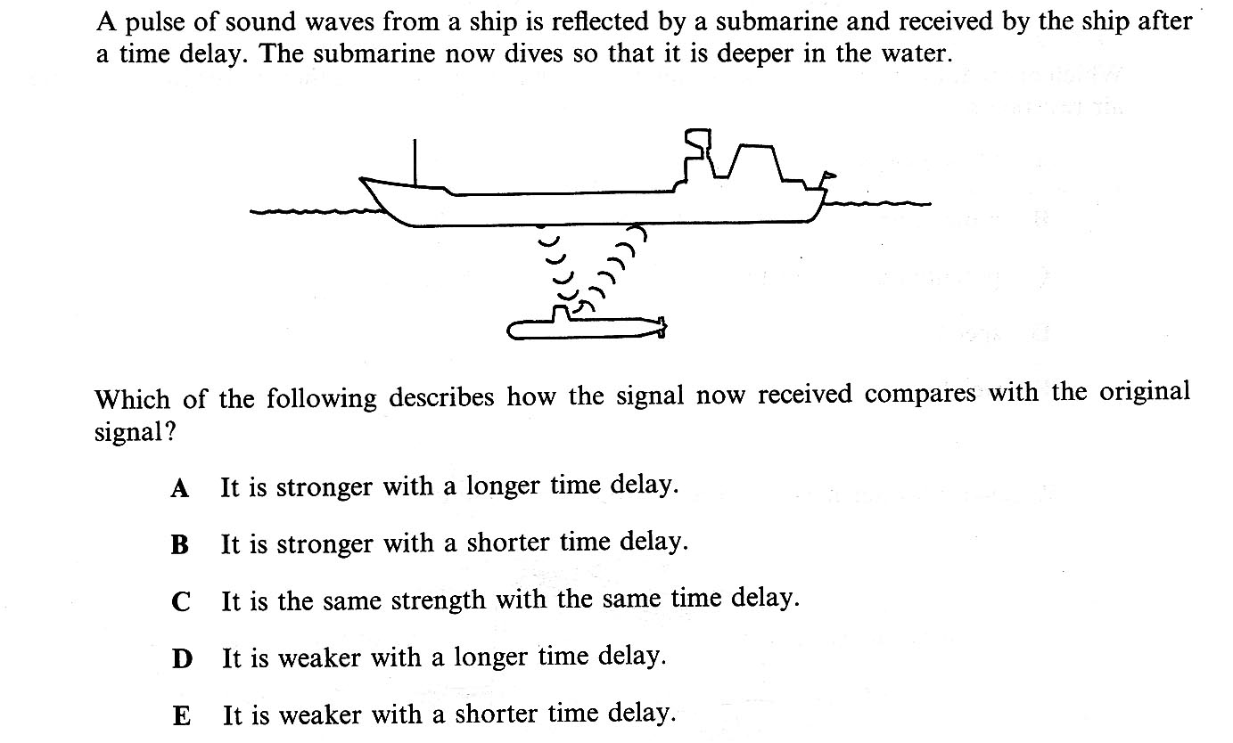

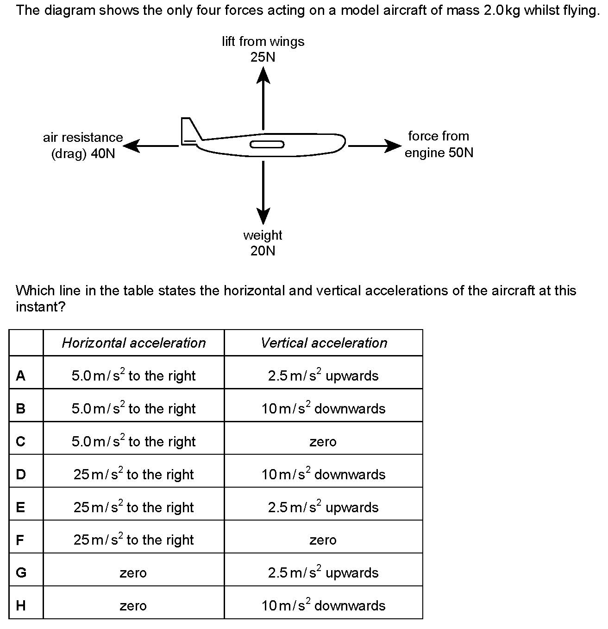
11.
12.

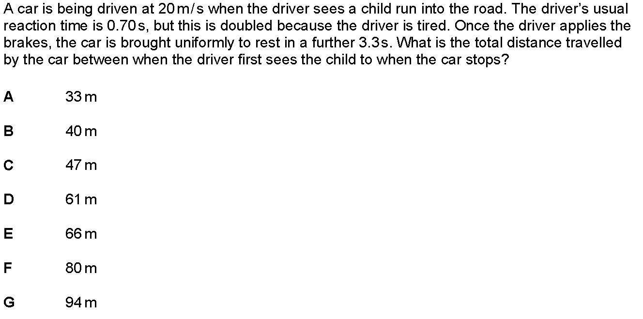

13.

Which of the five parachutists below is experiencing the largest upward force?

A a 100 kg parachutist falling at a constant 6 m/s, with a normal-sized parachute

B a 100 kg parachutist falling at 1 m/s, with a downwards acceleration of 8 m/s²

C a 60 kg parachutist falling at a constant 4 m/s, with a normal-sized parachute

D a 60kg parachutist falling at a constant 2 m/s, with an extra-large parachute

E a 100kg parachutist falling at 0 m/s (i.e. having just jumped out of the plane)
and accelerating downwards.

14.
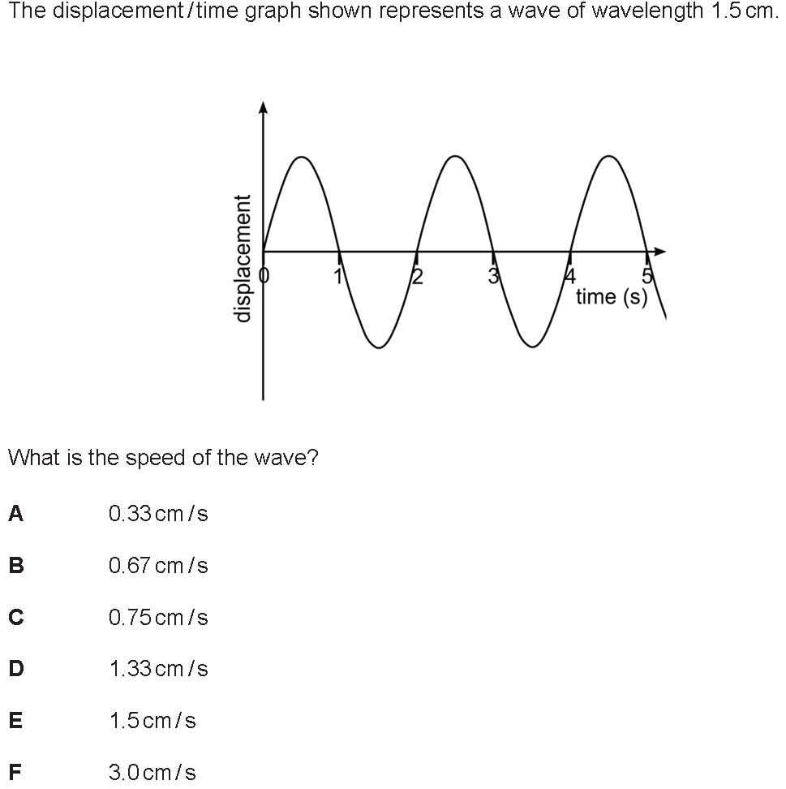

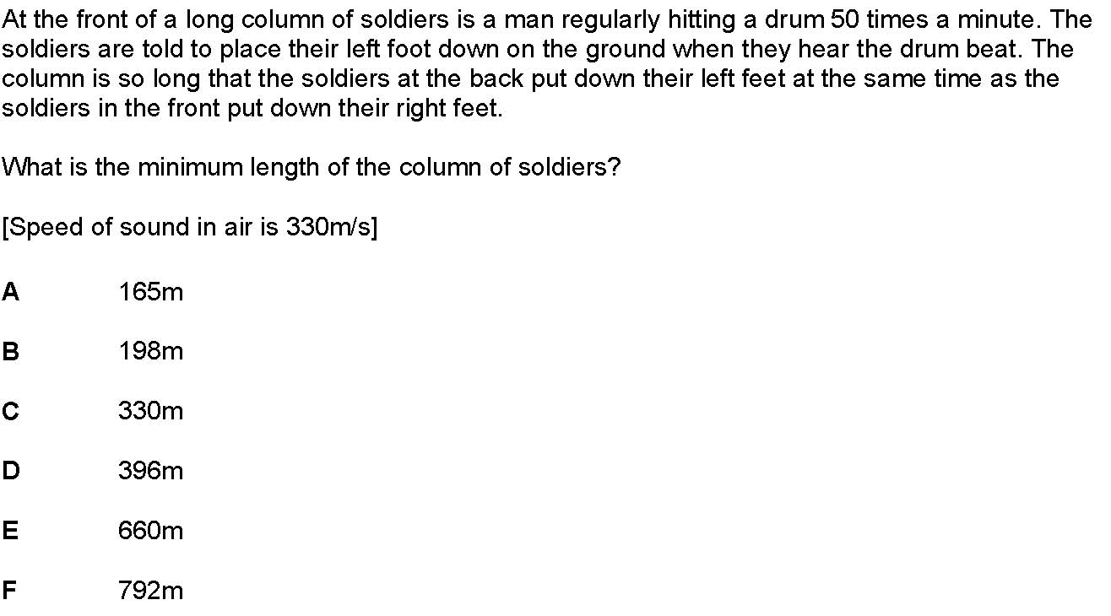
15.
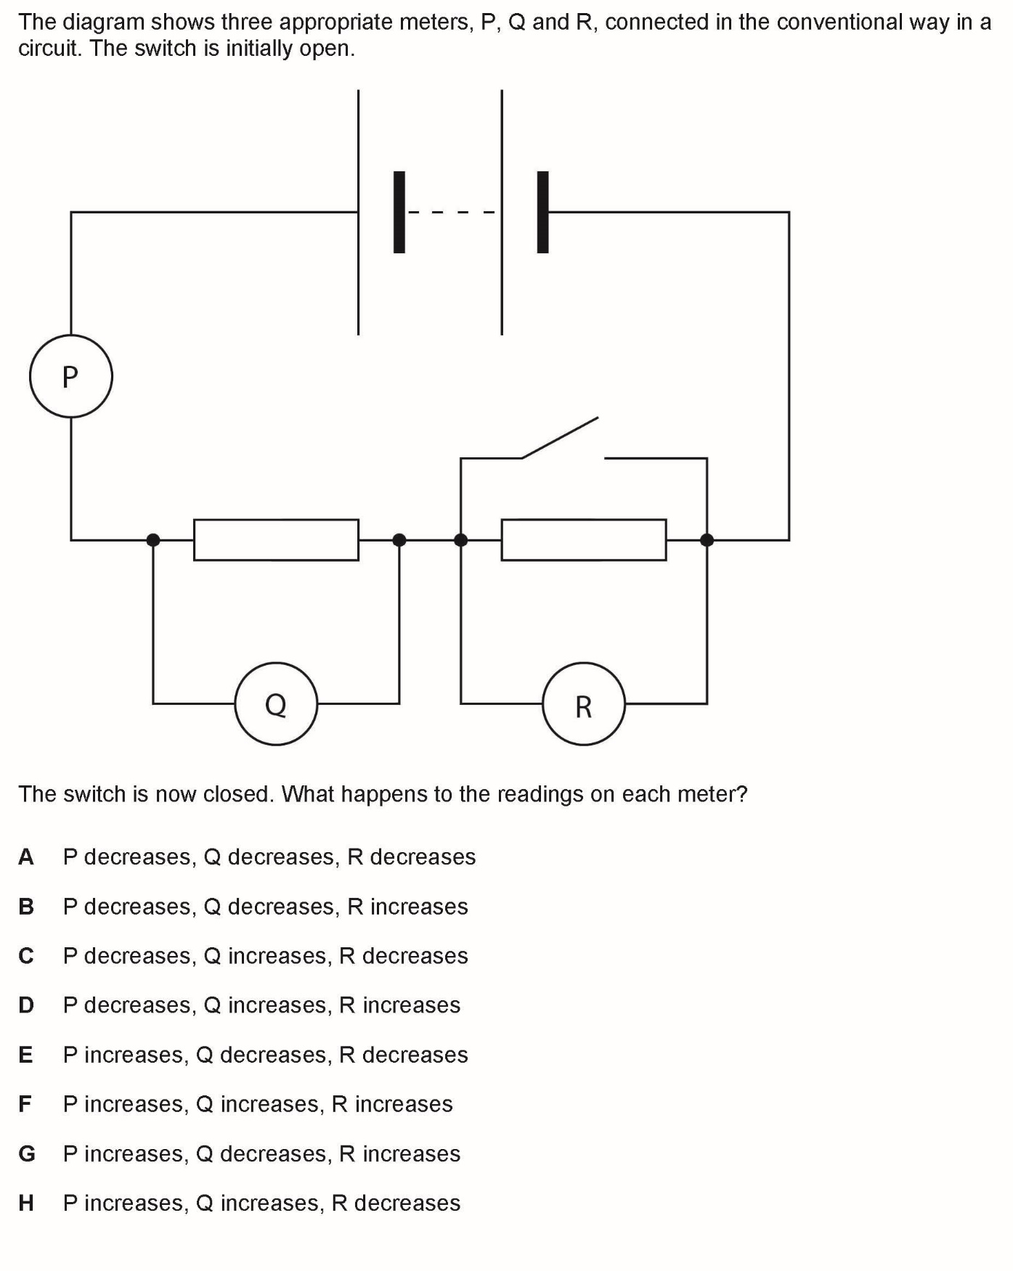
16.

17.

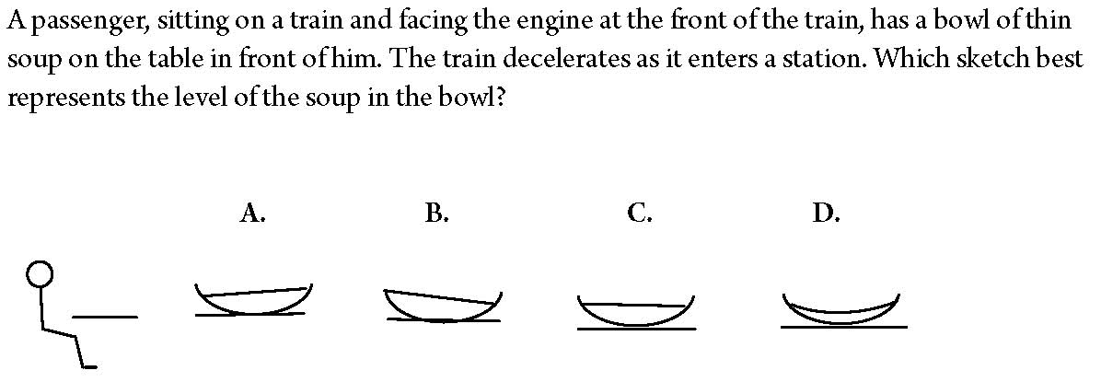

18.

The Squarks of Snozzland do lots of physics, but they use different units of measurement.

They measure force in Squishes and length in Yonders.

1 Squish equals 0.4 N and 1 Yonder = 5 cm.

A visitor from Snozzland to Earth makes a measurement of Earth’s atmospheric pressure, which in our units is 100 kPa or 10 N/cm².

How would the Squarks of Snozzland represent this measurement?

A 625 Squishes / yonder²

B 125 Squishes / yonder²

C 25 Squishes / yonder

D 1.25 Squishes / yonder²

E 1 Squish / yonder

19.

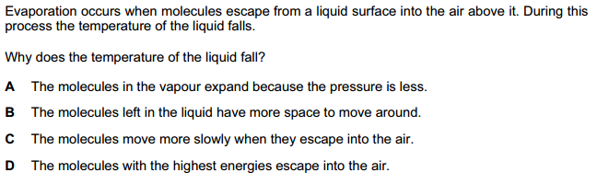

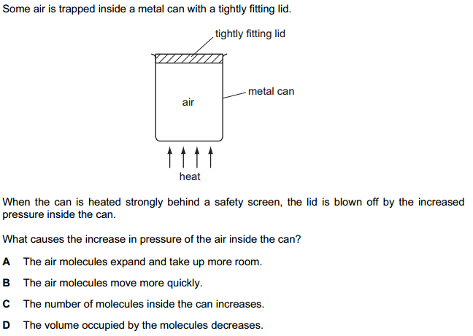
20.

Total for SECTION A = 20 marks

SECTION B

Choose ONE of the THREE questions in Section B.

Question 1 is about electrostatics

Question 2 is about waves in a ripple tank

Question 3 is about energy

Question 1 – electrostatics

- A small light plastic ball is hung on a nylon thread. The ball has a metal coating.
It is NOT charged.

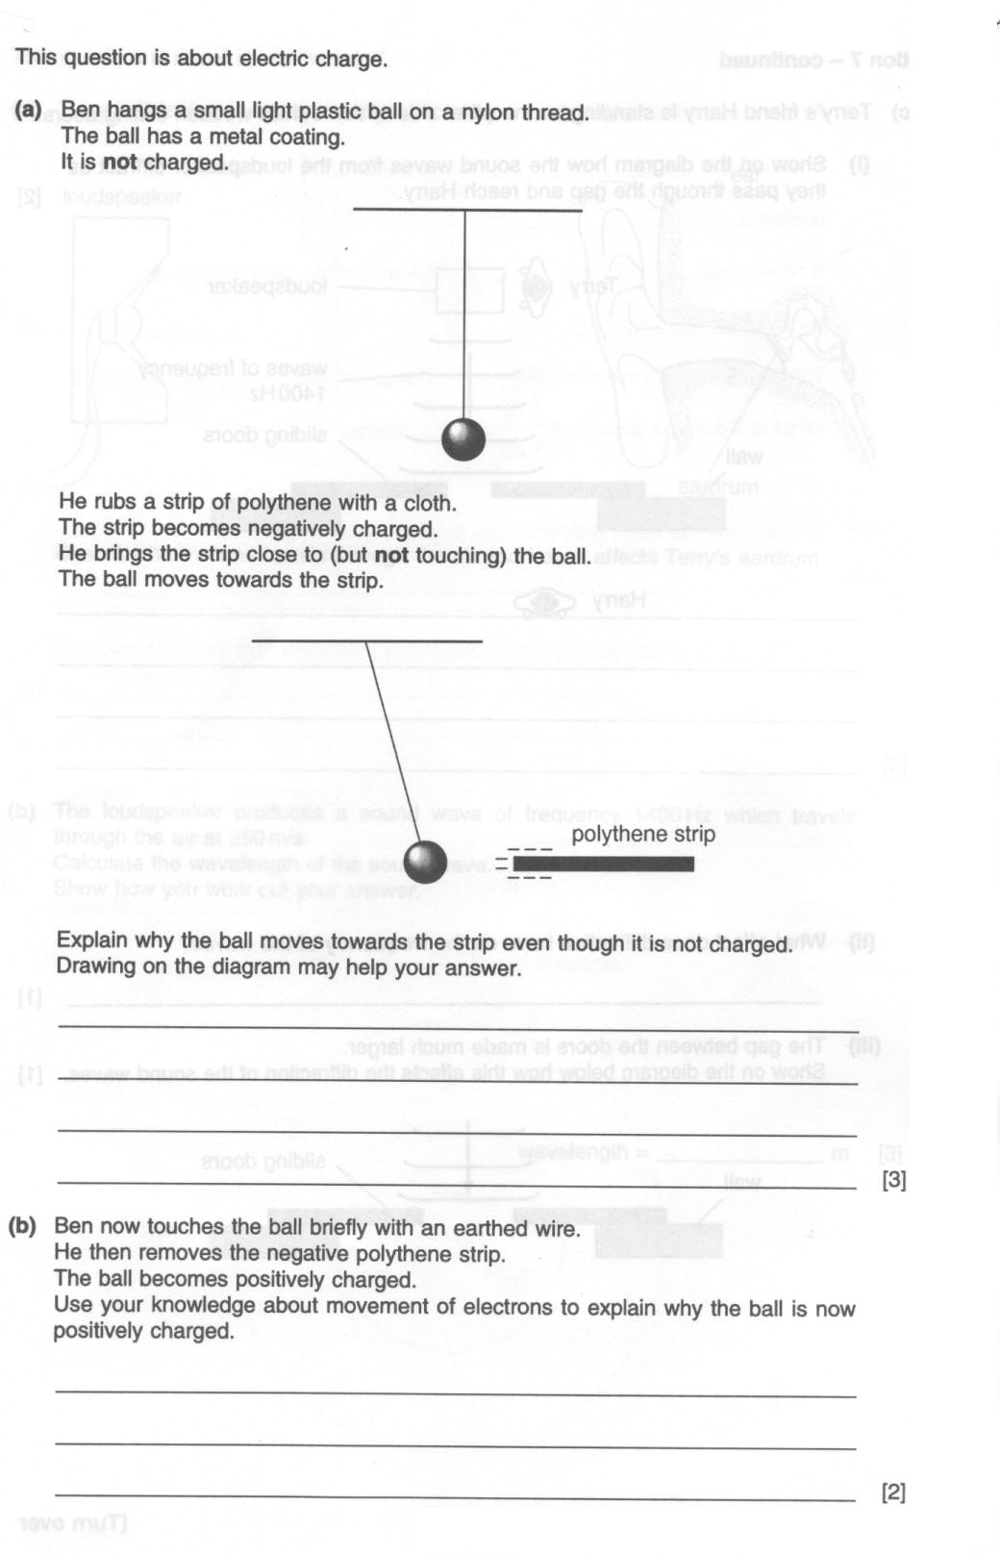

A polythene strip is rubbed with a cloth. The strip gains a negative charge.
The strip is brought close to, but NOT touching, the ball. The ball is attracted to the strip.

Explain why the ball is attracted to the strip, even though the ball is not charged. You can add to the diagram to illustrate your answer.

…………………………………………………………………………………………………………

…………………………………………………………………………………………………………

…………………………………………………………………………………………………………

………………………………………………………………………………………………… [3]

Keeping the strip in place, the ball is now touched briefly with an earthed wire.
The strip is then removed.
The ball becomes positively charged.
Use your knowledge of the movement of electrons to explain why the ball is now positively charged.

…………………………………………………………………………………………………………

…………………………………………………………………………………………………………

…………………………………………………………………………………………………………

…………………………………………………………………………………………………… [3]

- A thundercloud has formed some distance above a church spire.

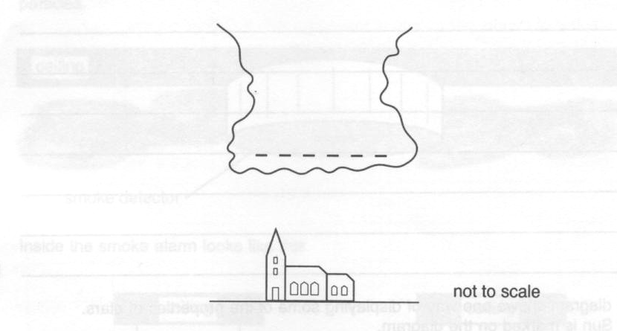

Negative charge has gathered at the bottom of the cloud.
In a lightning discharge, 15 C of charge is transferred from the cloud to the spire.

This takes 0.0005s and produces a very large current. Calculate the size of this current.

[1]

The electrical energy transferred from the cloud during the discharge is 150 MJ (where 1 MJ = one million J).
Calculate the voltage in MV between the cloud and the spire that transferred the 15 C of charge.

[2]

A lightning conductor is connected from the spire to the Earth to prevent damage during lightning strikes. It consists of a metal spike on the spire, connected by a thick copper cable to a metal bar buried in the earth.
Suggest why the cable is thick, and why it is made of copper.

…………………………………………………………………………………………………………

…………………………………………………………………………………………………………

…………………………………………………………………………………………………… [1]

(Total = 10 marks)

Question 2 – waves in a ripple tank

In an experiment in a ripple tank, straight water waves are produced with a frequency of 20 Hz.
The waves travel at a speed of 40 cm/s.

- Calculate the wavelength of the waves

[1]

- A hand stroboscope is used to observe the experiment. A stroboscope can be made out of a disc with 10 slits in it, equally spaced around its circumference.

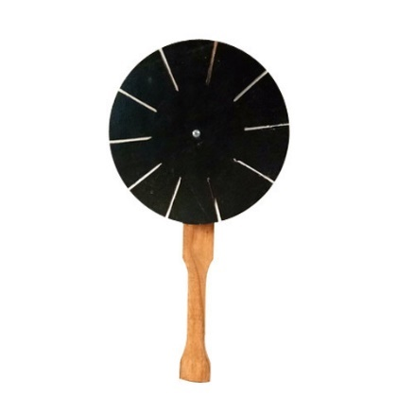

The disc is spun around, and you look through the slits in the disc as the disc rotates.
If you observe the waves through the rotating disc, you will see them several times a second.

Explain why the waves look stationary when looking through a stroboscope that is rotating at 2 rotations per second (i.e. at 2 Hz).

…………………………………………………………………………………………………...

…………………………………………………………………………………………………...

…………………………………………………………………………………………………...

…………………………………………………………………………………………………...

…………………………………………………………………………………………………...

…………………………………………………………………………………………………...

………………………………………………………………………………………… [3]

- Describe what you would see if you were to observe the experiment through the stroboscope rotating at a frequency of:

i) 1 Hz

…………………………………………………………………………………………………...

…………………………………………………………………………………………… [1]

ii) 4 Hz

…………………………………………………………………………………………………...

…………………………………………………………………………………………… [1]

iii) 1.9 Hz

…………………………………………………………………………………………………...

…………………………………………………………………………………………… [1]

- Suggest why, in movies, wheels sometimes seem to rotate backwards on forward-moving vehicles.
You can see this particularly clearly on wagon wheels or car wheels that have fancy hubcaps, like this:
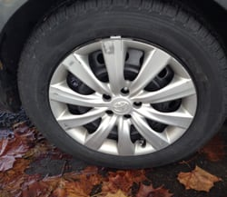


…………………………………………………………………………………………………...

…………………………………………………………………………………………………...

…………………………………………………………………………………………………...

…………………………………………………………………………………………………...

…………………………………………………………………………………………………...

…………………………………………………………………………………………… [3]

(Total = 10 marks)

Question 3 – energy

This question is about a moving walkway.
Moving walkways are often found in airports and shopping centres. Consider a moving walkway with the following specifications:
o Length = 60m
o Normal speed = 1.5m/s
o Idle (energy saving) speed = 0.5m/s
o Mass of moving section of walkway = 8000kg
o Friction force experienced by moving walkway = 2000N
Note: assume the frictional force is independent of the speed of the walkway, the number of passengers being carried, and remains constant.

- Assuming that the only energy losses are due to work done against the frictional forces experienced by the moving walkway, show that the power required to keep the walkway moving at normal speed, but with no passengers, is 3kW.

…………………………………………………………………………………………………...

…………………………………………………………………………………………………...

…………………………………………………………………………………………………...

………………………………………………………………………………………… [1]

- A group of passengers with a combined mass of 800kg step on to, and stand still on, the walkway which is moving at normal speed. The passengers can be taken to be initially at rest and are then accelerated from rest by the walkway.

Theory: The energy expended by the walkway, in accelerating the passengers from rest, is twice the kinetic energy gained by the passengers.

Calculate the total energy expended transporting the passengers to the end of the walkway.

…………………………………………………………………………………………………...

…………………………………………………………………………………………………...

…………………………………………………………………………………………………...

…………………………………………………………………………………………………...

…………………………………………………………………………………………………...

…………………………………………………………………………………………… [3]

To save energy, the walkway runs at a lower idle speed when there are no passengers on the walkway. When a passenger approaches the walkway, the speed increases to the normal operating speed.

- The same group of passengers, with a combined mass of 800kg, approach the walkway when it is running at the lower idle speed, and the walkway responds by increasing to the normal operating speed. They then step on to the walkway in the same manner as in part (b). Assume the time taken to speed up is very small compared to the time taken for the passengers to reach the end of the walkway.

Calculate the total energy expended transporting the passengers to the end of the walkway.

…………………………………………………………………………………………………...

…………………………………………………………………………………………………...

…………………………………………………………………………………………………...

…………………………………………………………………………………………………...

…………………………………………………………………………………………………...

…………………………………………………………………………………………… [3]

- Once the passengers have reached the end and stepped off the walkway, there is a delay before the runway slows down again.

Suggest and justify a suitable time delay, before the walkway slows down again, to make the walkway run as efficiently as possible.

…………………………………………………………………………………………………...

…………………………………………………………………………………………………...

…………………………………………………………………………………………………...

…………………………………………………………………………………………………...

…………………………………………………………………………………………………...

…………………………………………………………………………………………… [3]

(Total = 10 marks)

END OF PAPER – WELL DONE!

Total marks = 30

